MedVoice

Software Requirements Specification

Alva Dynamics LLC
September 20, 2015

Table of Contents

Introduction.
1.1. Purpose.
1.2. Scope.
  - Definitions, acronyms, and abbreviations
  - References.
  - Overview.
- Overall description
  - Product Perspective.
    - System Interfaces.
    - User Interfaces.
    - Hardware interfaces.
    - Software interfaces.
    - Communication interfaces.
    - Memory constraints.
    - Operations.
  - Product functions.
  - User Class and Characteristics.
  - Constraints.
  - Assumptions and dependencies
  - Apportioning of requirements
- Specific requirements.
  - External interfaces.
  - Functions.
  - Performance requirements.
  - Logical database requirements.
  - Design compliance.
  - Software system attributes.
    - Reliability.
    - Availability.
    - Security.
    - Maintainability.
    - Portability.
  - Organizing the specific requirements.
    - System mode.
    - Use Case.
    - Objects.
    - Feature.
    - Stimulus.
    - Response.
    - Functional hierarchy.
  - Additional comments.
4.0 Reports
1. Introduction

1.1. Purpose
The purpose of this Software Requirements Specification (SRS) document is to provide a description of the requirements for a MedVoice application. It will present the scope of the system, the constraints, the interfaces of the system, and the features of the system. The intended audience of this document is for all the stakeholders for this MedVoice application. This includes, the software developers, the project managers, and the users.
  - Scope
MedVoice is a social health awareness application.
1.2.1 Major Features
MF-1 Login or register for an account to access MedVoice
MF-2 View and modify account profile
MF-3 View dashboard, medical history, and result page

  - Definitions, acronyms, and abbreviations

Acronyms | Definition
SRS | Software Requirements Specification.
GUI | Graphical User Interface
App | Application
IEEE | Institute of Electrical and Electronics Engineers
Admin | Administrator
Ad | Advertisement
UI | User Interface
UC | Use Case

  - References:
[1] IEEE Recommended Practice for Software Requirements Specifications Software Engineering Standards Committee of the IEEE Computer Society. 1998.
[2] Wiegers, Karl, Software Requirements (3rd Edition), Microsoft Press 2013.

  - Overview:
The rest of this document will have two major sections and Appendixes and will be ended with an index for the SRS documents [1]. The second section will contain all the product outlines, perspective, function, interface, and user characteristics. The third section will include the some specific requirements (e.g. hardware requirements).

- Overall description

  - Product Perspective
The product is an internet-based system that will interact with users and other systems in the following ways:
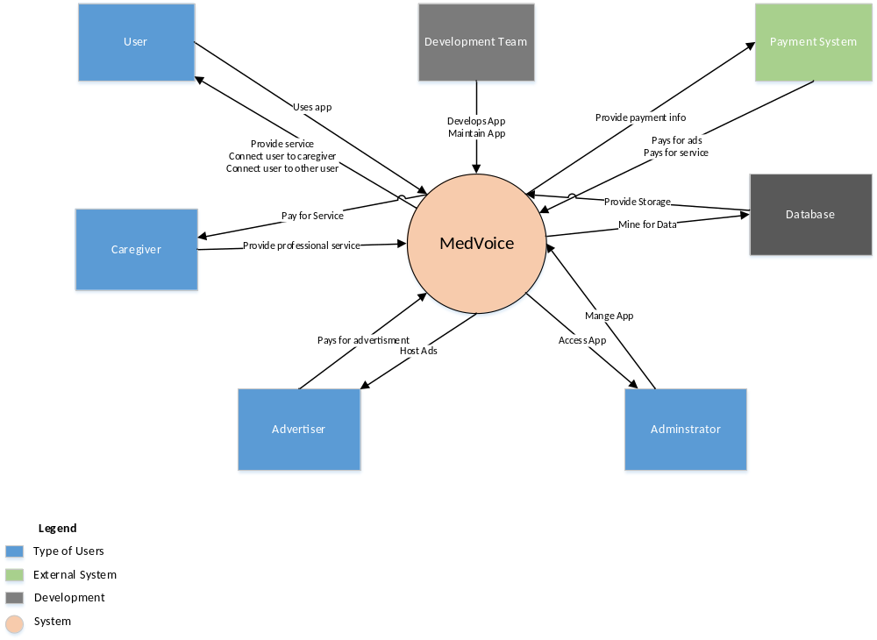
Figure 1: Context Diagram
    - System Interfaces
The interface for this software is a web browser.

    - User Interfaces
The user interface will be the web browser.

    - Hardware interfaces
Mouse and keyboard are required. A phone with internet connection is also required.

    - Software interfaces
The project software interface will be viewed on a phone. MedVoice will also be viewable on a web browser.

    - Communication interfaces
CI-1 MedVoice communication interface shall send a verification email to confirm that the user had registered at MedVoice.
CI-2 MedVoice communication interface shall send an email to the user if there are any suspicious activities such as three failed login attempts.
CI-3 MedVoice communication interface shall return the searched user/caregiver results to the user. Else, the MedVoice communication interface shall send a message to the user to say that the searched user/caregiver was not found.
    - Memory constraints
N/A.

    - Operations
Operation will be when the program is executed until the program is exited.

    - Site adaptation requirements
There is no site adaption requirement.

  - Product functions
The sequence diagrams below.
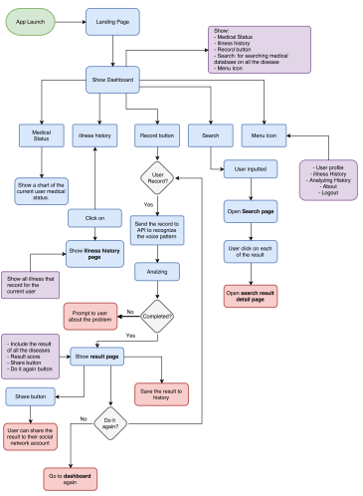
Figure 1. Sequence Diagram
  - User Classes and Characteristics
User Class | Description
Care Client (favored) | The care client is a user whom had registered for an account with the MedVoice app. If the care client wants a report, he must pay per each report. The user shall use an android device to access the app.
Subscribed user | A subscribed user is a person whom had registered for an account with the MedVoice app. The subscribed user had paid a subscription fee. The subscribed user is allowed to download an unlimited number of reports for free. The subscribed user shall use an android device to access the app.
Caregiver | The caregiver is a medical professional who is will provide medical advice and consultation to the user. The caregiver could access the app through the MedVoice website or the android app.
Advertiser | Advertiser is a person whom had paid MedVoice to host his ads on the app.
Administrator | An administrator is a person who works for MedVoice. The administrator monitors the activities on app and ensure that all the users adheres to the terms and condition agreement.

  - Constraints
System should be able to handle multiple users logged into the system. There is a maximum number of people working on implementing the project. MedVoice can only be built using the current software tools and IDE that are available. Another important constraint is time. There is a timeline for each releases of MedVoice. Any features not implemented in each release need to be moved to the next one or reprioritized.

  - Assumptions and dependencies
AS-1 Users are actual people and not robots
AS-2 App is well designed and easily navigable
AS-3 App have a fast response time
DE-1 Servers are able to handle all incoming traffic
DE-2 Users have the plugins that are required to watch videos
DE-3 Users have internet connection to access the application

  - Apportioning of requirements
Not Applicable.

- Specific requirements

  - External interface
The following describes the user interfaces.

  - Functions
3.2.1 Registering Users
3.2.1.1 Description
Users who wants to access MedVoice shall register for an account before access is granted. User shall provide their personal information to create an account.
3.2.1.2 Functional Requirements
Inputs
- User input their name, birthdate, gender, email address, password, and re-enter password again.
- User must agree to the terms and conditions before registration is complete.
Processing
- App checks user’s email address with database to ensure that no duplicate account was being created.
- App detect that user had agreed to the terms and conditions
- App also detect that all required fields were filled out
- App checks that the password and the re-entered password matched
Output
User is temporarily registered and the system automatically set a confirmation email to the user’s email address.
Error Handling
- If the user typed an email address that is already registered in the database; then the system shall display an error message to inform the user that the email was used.
- If the password and the re-entered password do not match; the system shall display an error message that said the password does not match and ask the user to re-enter the password.

3.2.1 Login Users
3.2.1.1 Description
Users who wants to access MedVoice shall login before access is granted. User shall provide their username/email and password to login.
3.2.1.2 Functional Requirements
Inputs
- User input their username or email address and password.
Processing
- App checks that the username or email address matches the password stored in the database
Output
User is logged into MedVoice
Error Handling
- If the user typed an unregistered username or email address the system shall display an error to say that there isn’t any username/email address registered
- If the password did not match the username/email address in the database, the system shall display an error to inform the user that the password was incorrect.

3.8 Delete Registered Account
3.8.1 Description
This feature shall allow registered users to delete their account from the MedVoice application.
3.8.2 Functional Requirements
Input
- User click on the delete account button located in their profile.
- User click the OK button to confirm that he wants to delete the account.
Processing
- App shall detect the delete account button is pressed.
- App shall check that the user had clicked the OK button to confirm.
Output
- App shall delete the user’s account information from the database.
Error Handling
None

  - Performance requirements
PER-1 Coding shall be done to optimize to handle processing of multiple users using the system.
PER-2 Report download should be completed within 1 minute from the time the user had purchased and requested the report over a 10 Mbps or faster internet connection.
PER-3 System shall display confirmation messages to users within an average of 4 seconds to a maximum of 10 seconds after the user submits information to the system.

  - Logical database requirements
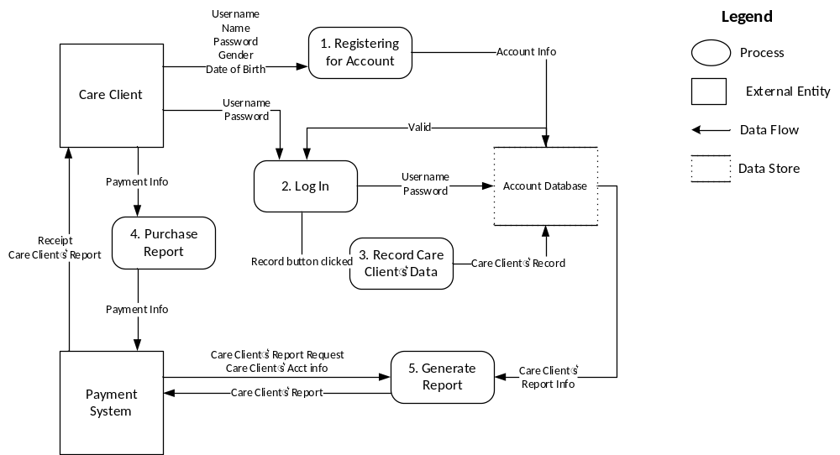Figure 2: Data Flow Diagram
  - Design constraints

    - Standards compliance
All HTML code shall conform to the HTML 5.0 standard.

  - Software system attributes

    - Reliability
The Software shall be functional during execution. The app shall not crash while the user is using it.

    - Availability
The Software shall be accessible by Internet Explorer, Firefox, Chrome, and Safari web browsers. Also, the app shall be accessible by Android. The app shall be available for the users at least 99.9% of the time, excluding scheduled maintenance windows.

    - Security
The Software should have security features for only users that have access to the Software. The app shall require users to log into the app to access the app’s features. The app shall permit users to access only the report that pertained to them.

    - Maintainability
The code shall be well documented and most modules will be reusable.

    - Portability
The code used in this program will be completely portable, allowing the code to go from one application to another as long as they comply with the hardware and software requirements detailed in this document.

  - Organizing the specific requirements

    - System mode
Single mode of operation (normal mode).

    - User class
There are multiple users of the Software.

ID and Name: | UC-1 Register for an Account
Primary Actor: | Care Client Secondary Actor: Care Giver  MedVoice app
Description: | The user shall register for an account on MedVoice application by clicking on the Register button on the MedVoice app. The user must enter in their email address, username, and a password to register.
Trigger: | User downloaded MedVoice app and clicked on Register for an account button.
Preconditions: | PRE-1 User must have a valid email address  PRE-2 Username must be available  PRE-3 Password must be at least 8 characters long with numbers or a special character
Postconditions: | POST-1 MedVoice application system shall send a verification email to the user’s email address  POST-2 The user shall clicked on the verification link in the email to verify their email address and the account shall be made  POST-3 User’s account information shall be stored in the MedVoice system database
Normal Flow: | 3.0 Register for an Account  1. Click on Register button on MedVoice app  2. Enter a valid Email address  3. Enter a Username that is available  4. Enter a password that is at least 8 characters long with numbers or a special character
Alternative Flow: | 3.1 Register using a third-party application  1. User shall be able to sign in using either his Jawbone, Google+, Facebook, Twitter, or LinkedIn account.  2. Sign in using their email and password
Exceptions: | 3.0 E1 Invalid Email address  3.0 E2 Username is taken  3.0 E3 Password is not long enough or does not have a number or a special character  3.1 E4 Password is incorrect
Priority: | High
Frequency of Use: | At least hundreds of users a day.
Other information:
Assumptions: | Assumes user have an email address  Peak usage when application first become available

ID and Name: | UC-2 Login to MedVoice Application
Primary Actor: | Care Client Secondary Actor: Care Giver  Administrator
Description: | The user shall login to the MedVoice application when the application opens. The user must enter in their email address, username, and a password to login.
Trigger: | User opened the MedVoice application
Preconditions: | PRE-1 User have a registered account at MedVoice
Postconditions: | POST-1 MedVoice application system shall send a verification email to the user’s email address  POST-2 The user shall clicked on the verification link in the email to verify their email address and the account shall be made  POST-3 User’s account information shall be stored in the MedVoice system database
Normal Flow: | 3.0 Login to MedVoice  1. Open MedVoice application  2. Enter username  3. Enter password  4. Click Login button
Alternative Flow: | 3.1 Reset user’s password  1. Click on “Forgot Password?” button  2. User enter email address that was used to register for MedVoice account  3. Application shall check that email address was registered and stored in MedVoice database  4. MedVoice application shall send an email with a temporary password  5. User use temporary password to login to MedVoice app.  6. User is prompted to create a new password
Exceptions: | 3.0 E1 Invalid Email address  3.0 E2 Username is not in MedVoice database  3.0 E3 Password is invalid
Priority: | High
Frequency of Use: | At least hundreds of users a day.
Other information: | 1. If user input the wrong information (email, username, or password) after five failed attempts, the system shall send an email to the user to report that suspicious activity have been detected.
Assumptions: | Peak usage when application first become available

ID and Name: | UC-3 Sending Chat
Primary Actor: | Care Client Secondary Actor: Care Giver  Administrator
Description: | The user shall be able to initiate a chat with his target and user shall be able to participate in group chat
Trigger: | User searched and selected his chat target
Preconditions: | PRE-1 User have a registered account at MedVoice
Postconditions: | POST-1 MedVoice application shall send offline status once no online device is detected  POST-2 MedVoice application shall clean up resources once no online device is detected
Normal Flow: | 3.0 Sending Chat  1. Click on Chat  2. Search for chat target  3. Select chat target  4. Type message for target  5. Click Send  6. Application shall send message to Session Server  7. Application shall broadcast message to target  8. Application shall store message to session
Alternative Flow: | 3.1 Sending Group Chat  1. Click on “Create Group Chat” button  2. Create a Group Name  3. Search for chat targets  4. Select chat target and invite target to Group Chat  5. Type message for target  6. Click Send  7. Application shall send message to Session Server  8. Application shall broadcast message to targets  9. Application shall store message to session  10. Target click “Leave” to exit Group Chat
Exceptions: | 3.0 E1 Target had deleted his account
Priority: | High
Frequency of Use: | At least thousands of users a day.
Other information: | 1. If user used inappropriate language or used chat to solicit other users; application shall flag that user.
Assumptions: | Peak usage when application first become available

ID and Name: | UC-4 Record Audio
Primary Actor: | Care Client Secondary Actor: MedVoice Application
Description: | The user shall be able to record his voice. The MedVoice app will analyze the user’s voice and pulse through frequency and wavelength analyzation
Trigger: | User select the Audio button
Preconditions: | PRE-1 User have a registered account at MedVoice  PRE-2 User have logged into MedVoice
Postconditions: | POST-1 MedVoice application shall analyze the user’s audio recording.  POST-2 MedVoice application shall store the user’s audio recording inside the database
Normal Flow: | 3.0 Recording the user’s voice  1. Click on Audio  2. Follow the instructions on the Audio page  3. Perform the audio recording  4. MedVoice app shall store the audio recording in the database
Alternative Flow: | 3.1 Ending the audio recording  1. Click on the stop button  2. Application shall stop the audio recording  3. Application shall delete the incomplete audio recording
Exceptions: | None
Priority: | High
Frequency of Use: | At least hundreds of users a day.
Other information: | None
Assumptions: | Peak usage when application first become available

ID and Name: | UC-4 Record Video
Primary Actor: | Care Client Secondary Actor: MedVoice Application
Description: | The user shall be able to record his pulse using the MedVoice’s video recording. The MedVoice app will analyze the user’s voice and pulse through frequency and wavelength analyzation
Trigger: | User select the Video button
Preconditions: | PRE-1 User have a registered account at MedVoice  PRE-2 User have logged into MedVoice
Postconditions: | POST-1 MedVoice application shall analyze the user’s video recording.  POST-2 MedVoice application shall store the user’s video recording inside the database
Normal Flow: | 3.0 Recording the user’s pulse  1. Click on Video  2. Follow the instructions on the Video page  3. Perform the Video recording  4. MedVoice app shall store the Video recording in the database
Alternative Flow: | 3.1 Ending the video recording  1. Click on the stop button  2. Application shall stop the video recording  3. Application shall delete the incomplete video recording
Exceptions: | None
Priority: | High
Frequency of Use: | At least hundreds of users a day.
Other information: | None
Assumptions: | Peak usage when application first become available

ID and Name: | UC-4 Adding a Friend
Primary Actor: | CareClient Secondary Actor: CareGiver  MedVoice Application  Administrator
Description: | The user shall be able to add another CareClient or CareGiver as a friend.
Trigger: | User select the add friend button
Preconditions: | PRE-1 User have a registered account at MedVoice  PRE-2 User have logged into MedVoice  PRE-3 User is inside the target’s Profile Page
Postconditions: | POST-1 MedVoice application shall store the target’s name inside the user’s friend list.
Normal Flow: | 3.0 Adding another CareClient or CareGiver to the user’s friend list  1. Click on add friend  3. App shall send a message to the target informing him that another user wants to add him as a friend  2. If the target accepts the friend request, MedVoice app shall store the target’s name to the user’s friend list and store the user’s name to the target’s friend list
Alternative Flow: | 3.1 Removing a friend  1. Click friend list  2. Click on the target user to be removed  3. Click remove friend  4. Application shall display a pop up message to ask user to confirm that he wants to defriend the target  5. If the user clicks ok, the application shall remove the defriended target from the user’s friend list
Exceptions: | 3.0 E1 The username of the target was not found  3.1 E2 The target user had deleted his account
Priority: | High
Frequency of Use: | At least hundreds of users a day.
Other information: | None
Assumptions: | Peak usage when application first become available

    - Objects
See the Sequence Diagram in Figure 1.

    - Feature
This software contains no external features.

    - Stimulus
This software supports submission from the Software.

    - Response
All responses to user input are described in section 2.

    - Functional hierarchy
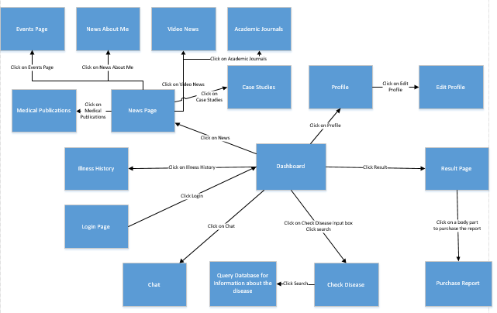
Figure 3: Dialog Map

  - Additional Comments
No additional comments.
4.1 Reports
4.1 New User Registered Report
Report ID | MedVoice RPT-1
Report Title | New users registered
Report Purpose | Management shall review the new user registered report to determine if business objectives has been reached. Advertisers shall review this report to access the numbers of new users registered to determine if they want to create ads for the application.
Priority | High
Report Users | Management and Advertisers
Data Sources | Account database
Frequency and Disposition | Report is generated on the last week of the month and sent automatically to management and advertisers once a month. Data in this report are dynamic. At the request of either user, the system may generate extra reports at any time. Reports are sent through emails and can be view on desktops, smartphones, tablets, and may be printed if the display device permits printing.
Latency | A complete report is displayed within 3 seconds after request or it is automatically sent on Monday of the last week of the month.
Visual Layout | Portrait mode
Header and Footer | Report header shall contain the report title and the date and year. The footer shall contain the page number
Report Body | Fields shown and column headings:  - Number of new registered users for the month  - Total number of new registered users for the year  - A list of new registered users with their usernames
End-of-Report Indicator | A line that reads: “This concludes the total number of new registered users for the month: and year: time stamped:”
Interactivity | User may see previous month reports. User may also view a list of usernames of new registered users
Security Access Restriction | Only management with access and advertisers may view this report

Report ID | MedVoice RPT-2
Report Title | Medical Status
Report Purpose | Management shall review the Medical Status report to understand the predispositions of their user’s demographics. Insurance companies and pharmaceutical companies shall review the report to gather data about certain locale and their medical depositions.
Priority | High
Report Users | Management, insurance companies, and pharmaceutical
Data Sources | Account database
Frequency and Disposition | Report is generated on the last week of the month and sent automatically to management once a month. Data in this report are dynamic. At the request of management, the system may generate extra reports at any time. Reports are sent through emails and can be view on desktops, smartphones, tablets, and may be printed if the display device permits printing. Data shall contain de-identified information.
Latency | A complete report is displayed within 3 seconds after request or it is automatically sent on Monday of the last week of the month.
Visual Layout | Portrait mode
Header and Footer | Report header shall contain the report title and the date and year. The footer shall contain the page number
Report Body | Fields shown and column headings:  - Common diseases such as diabetes and the number of users who are prone to those diseases  - An age range and the number users with a disposition for certain diseases  - The gender and number of users with a disposition for certain diseases
End-of-Report Indicator | A line that reads: “This concludes the Medical Status of MedVoice users for the month: and year: time stamped:”
Interactivity | User may see previous month reports.
Security Access Restriction | Only management with access, insurance companies, and pharmaceutical companies may view this report

